|  |  |
| --- | --- |
| **Project Title** | **Designing an Automatic Data Collection and Storage System with AWS Lambda and Slack Integration for Server Availability Monitoring and Slack Notification** |
| **Technologies** | **AWS Lambda, Amazon RDS, CloudWatch, Slack API** |

Step 1 – Create the AWS RDS postgresql database instance and create the table to store data

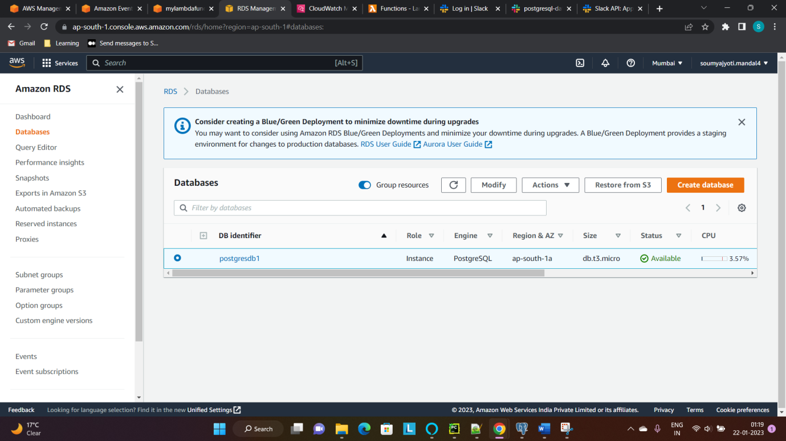

Step 2 – Create an AWS Lambda Function (no need to write code as of now)

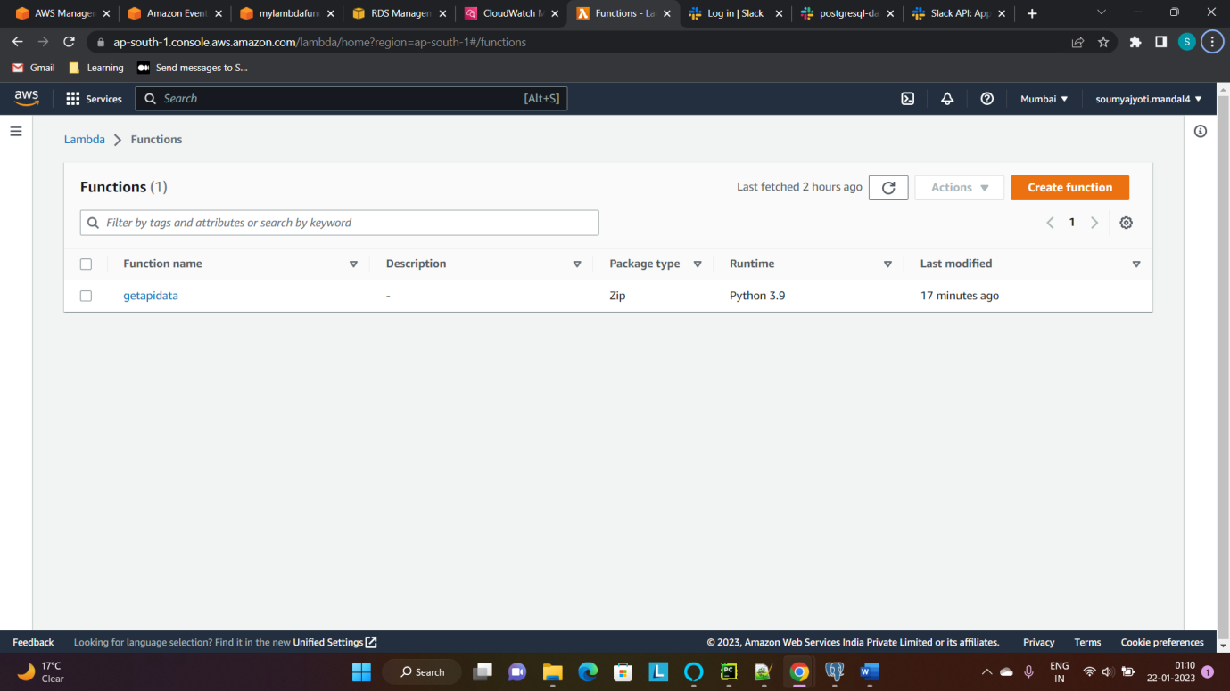

Step 3 – Create Event (scheduled) which will trigger the Lambda function every 1 minute by adding it in the Target

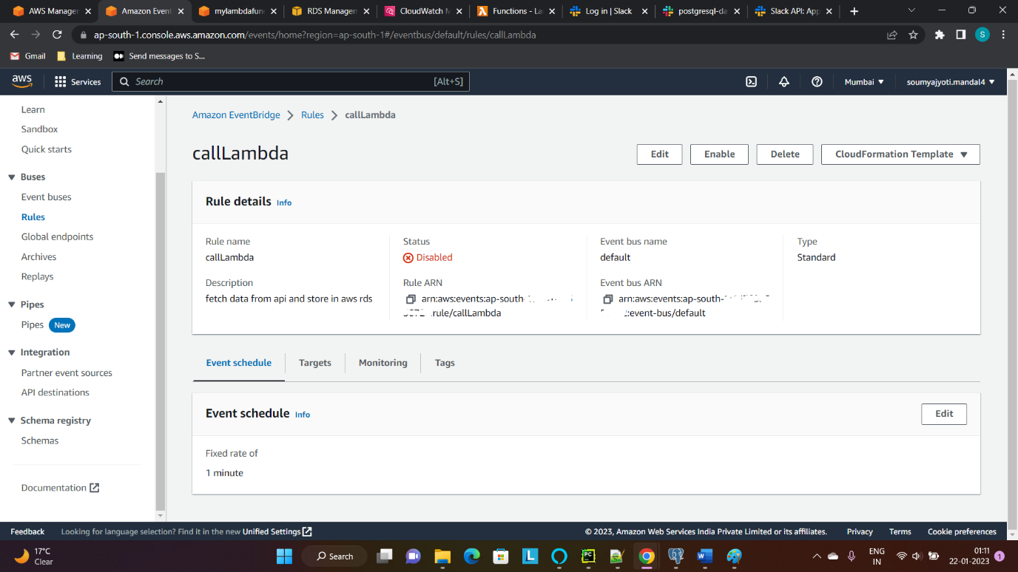

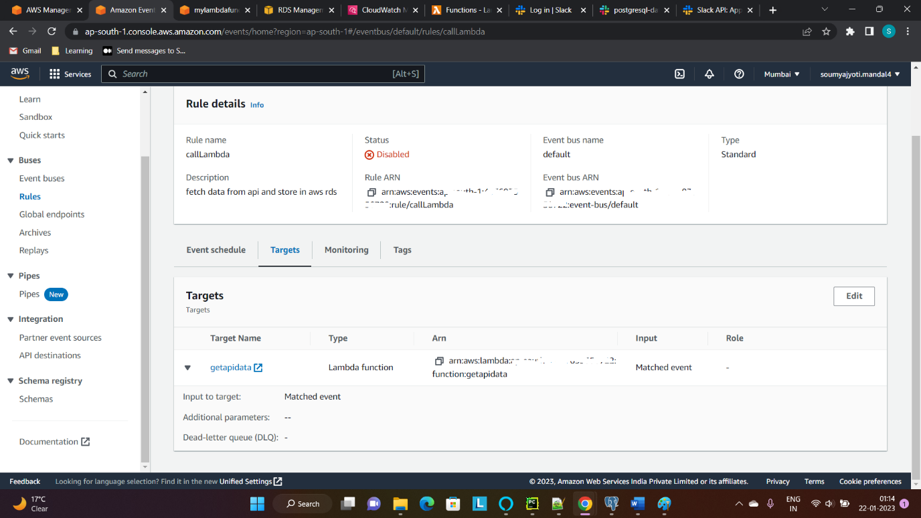

Step 4 – Create another event (pattern) which will trigger the Lambda function when a failure or db stopped RDS Instance Event is found

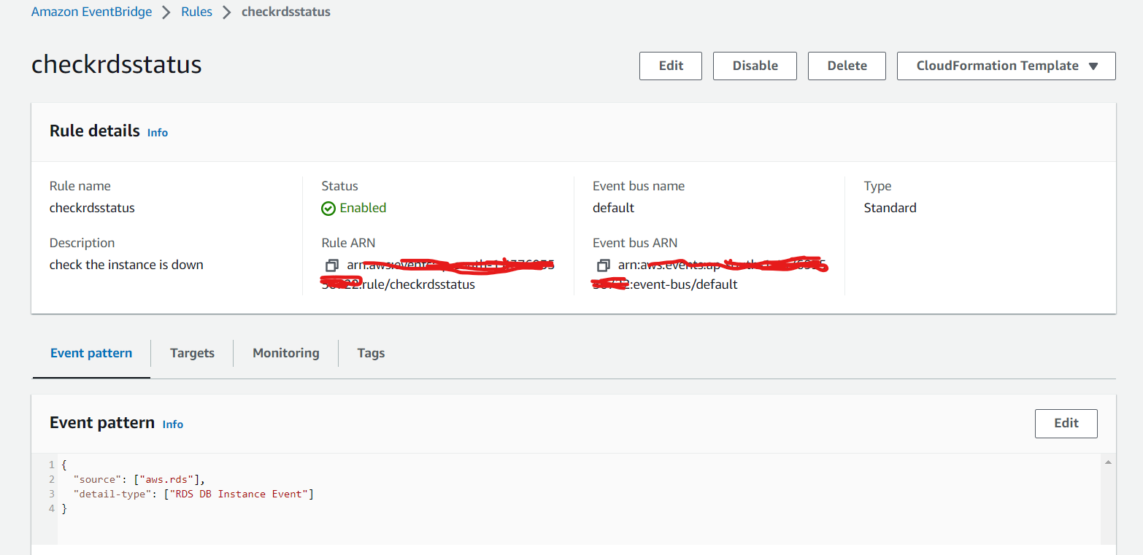

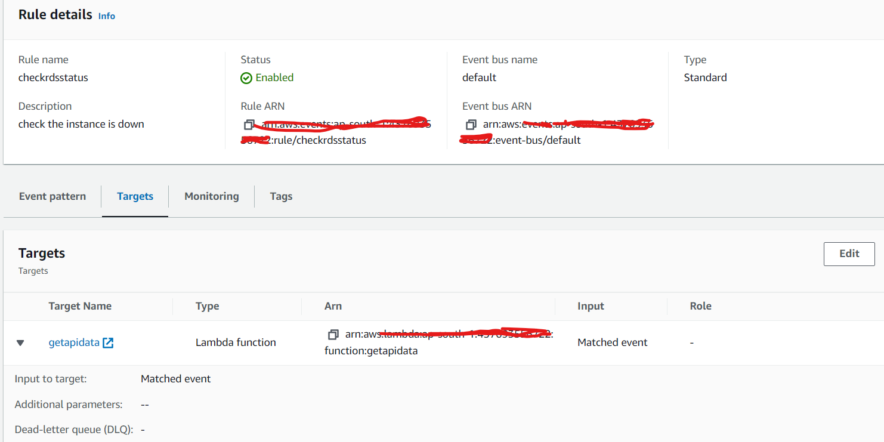

Step 5 – The events should be visible in the Triggers section of the Lambda function

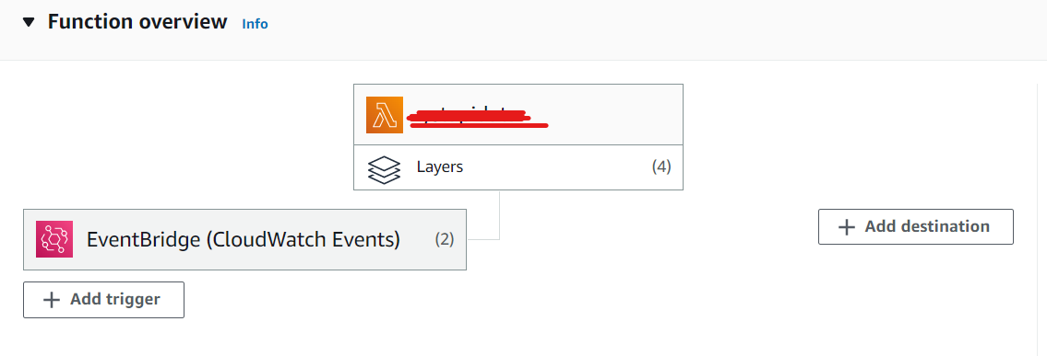

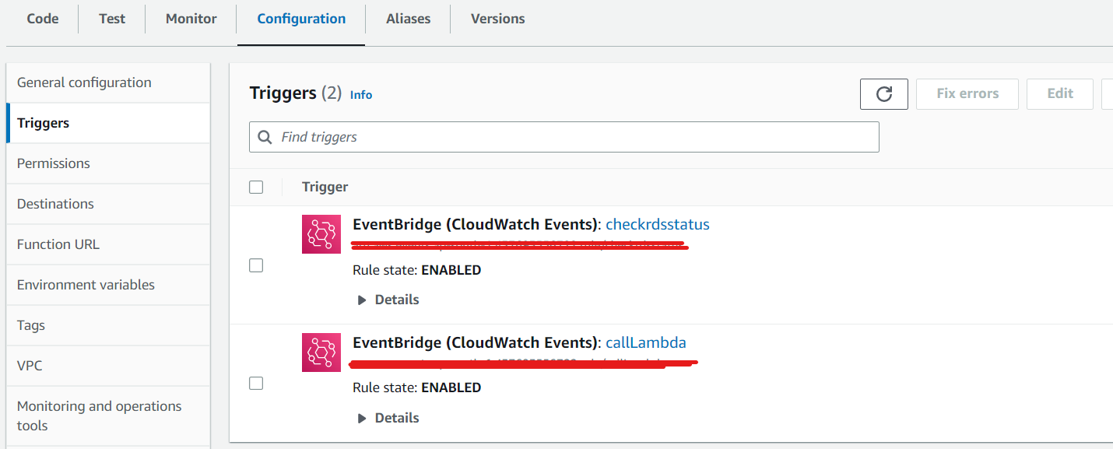Step 6 – Create Slack channel to receive notifications

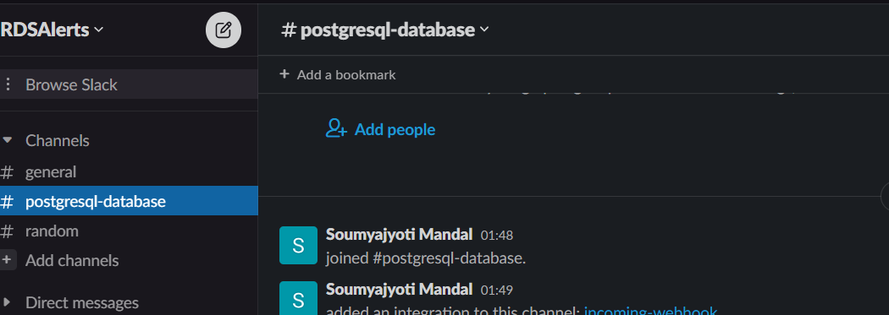

Step 7 – Create app and install it to workspace and add it to channel. The app should have the following scopes. Note the OAuth token when app is installed

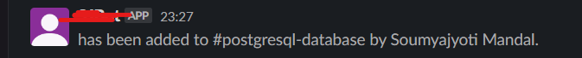

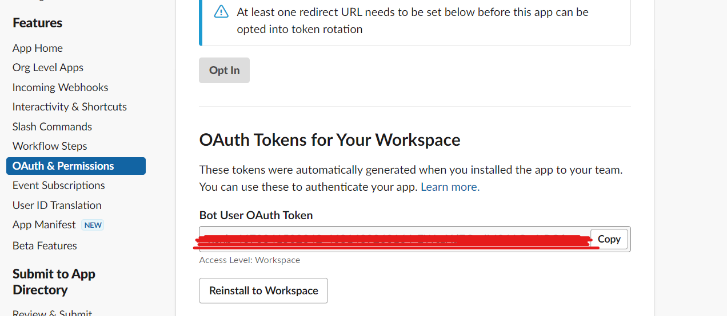

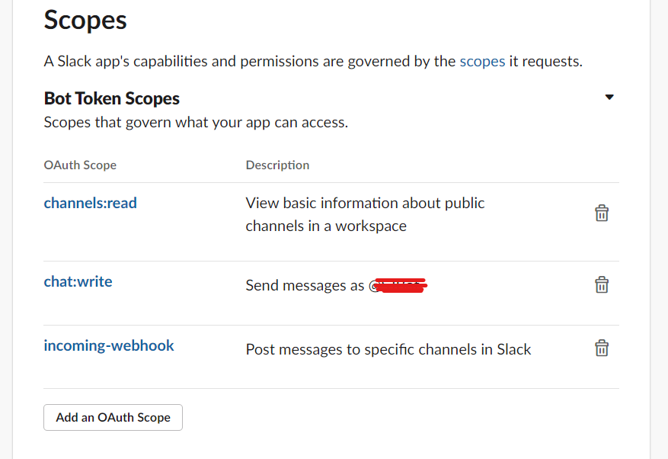

Step 8 – Write the Lambda function to fetch data from API and store it in DB or send notification to Slack community when DB is unavailable, depending upon the event that triggered the function



Notification sent to Slack channel when RDS instance is unavailable.

